Family and Consumer Education
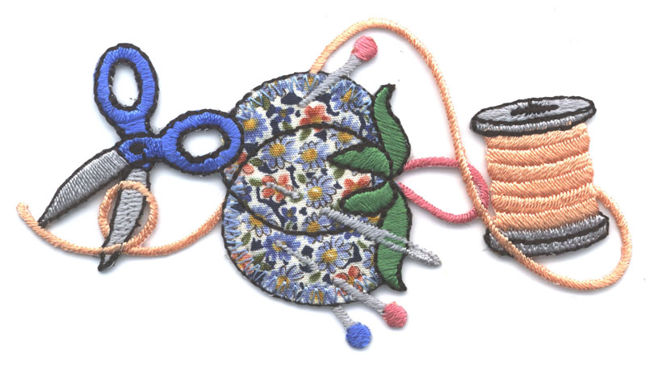
Clothing & Design
Mrs. Amundson
Room 106
Course Description: This introductory course is designed for students who have an interest in learning about basic sewing construction and design. Projects vary from simple sewing projects to more complicated projects of individual choice. Students will be encouraged to challenge themselves while working at an individual pace and comfort level.
Course Goals:
- Students will understand basic sewing patterns.
- Students will demonstrate accurate measuring skills.
- Students will demonstrate various sewing techniques.

Grading Procedure: Each student will be graded on daily participation, individual projects and daily assignments.

Assignments:
- Assignments will be collected and graded based on assignment rubrics.
- Participation points will be given on a daily basis.
- It is YOUR responsibility to see me for make-up work.
- Projects need to be completed IN CLASS. If you miss class and need extra time, see me about coming in before or after school.
Expectations and Grading:
- Be on time.
- Be respectful. This means of fellow students and their property, school property and me!
- Always come prepared for class.

- No food or drinks in the classroom (water is acceptable).
- Be productive!
- Challenge yourself!
- Have fun!

