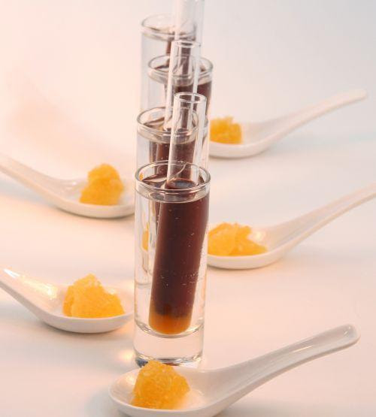
Food Science

Instructor: Mrs. Amundson
Room #: 164/163
Phone #: 715-537-5627 ext 164/163
E-mail: amundsonc@barron.k12.wi.us

WELCOME TO FOOD SCIENCE
Food science is a growing field of study that integrates information from a broad spectrum of curricula. In this course, we will examine science concepts related specifically to food. As you learn food science basics, you will also gain knowledge and skills in food preparation, food selection, nutrition analysis, problem solving, and critical thinking. The study of food can benefit you as you make daily food choices, both now and in the future, and understand the health impacts of those choices. In addition, you will gain knowledge needed to evaluate future technological advances as they are applied to food as well as provide an opportunity to explore a range of career opportunities related to food science.

Units will include:
- Food Science & the Scientific Method
- Sensory Evaluation
- Elements and Relation to Food
- Simple Carbohydrates
- Complex Carbohydrates
- Fats
- Proteins
- Phytochemicals

Grading will be based on the following:
- Homework
  - Assignments/Worksheets
  - Projects
- Quizzes/Exams
  - Labs/Experiments

Kitchen Safety and Sanitation
Students are responsible for maintaining a safe and sanitized work area in their kitchen. The first week of class will be dedicated to understanding these principles, including prevention of foodborne illness. If a student fails to maintain a safe and sanitized kitchen, the instructor has the right to dismiss that student from the lab. The student will also lose all points for the day’s lab.

Labs/Experiments
After ONE missed lab, you will be required to complete a makeup lab and/or worksheet in order to make up the points (1st lab free, 2nd -begin make-up assignment). Each lab/experiment is worth at least 20 points so be sure to complete the make-up assignment in order to maintain a good grade in the class.

Class Expectations:

BE GOLDEN, LIKE A BARRON BEAR
- Be respectful
- Be organized
- Be energized
- Be on time
- Wear face covering, gloves while in the lab, social distance when you can, wash hands, and sanitize.

Failure to live up to these expectations will result in consequences deemed appropriate by the instructor. BRING ALL MATERIALS WITH YOU AT THE BEGINNING OF THE CLASS.

Excused Absences:

If you have an excused absence, it is your responsibility to check google classroom and/or see me for your missing assignments. Students with excused absences will receive 2 days per absent day to complete missed assignments. Assignments turned in following this period will have the late work policy applied.

Unexcused Absences:
Unexcused absences will result in receiving ZERO points for the day’s activities/participation.

Late Work:
For assignments one day late, there will be a 10% penalty off the total grade prior to grading. Any assignments turned in one day or later up until the end of the grading period can be turned in for 50% credit (prior to grading).

Honor Code:
Any student caught cheating and/or plagiarizing on any given assignment/quiz/exam will have consequences as outlined in https://www.barron.k12.wi.us/cms_files/resources/18-19%20Student%20Handbook.pdf

I am looking forward to the opportunity to work with you throughout the trimester. By signing below, you are stating you understand the requirements of the course and the expectations of yourselves. Please have your parent/guardian sign below as well to be sure they are aware of the requirements/expectations of the course as well.

________________________________________________________________________________________________

Food Science
Please read and sign:
I have read and understood the expectations and requirements of Food Science.

Student Name (please type):

Student Signature: ______________________________________________________________________

Parent/Guardian Signature: ___________________________________________________________ Date: _____________

Parents/Guardians: If you have any special skill/experience in relation to the class or would just like to come observe the class itself, please feel free to call or email me to set up a time, or write your phone number below for me to contact you. Also, please feel free to contact me if you have any concerns/suggestions about the class or your child. I look forward to working with you and your child(ren) this trimester!

